**DAILY REPORT**

**Student Name :SINDHU.N**

**Class and Sec : VI B**

**USN :4AL17CS094**

**DATE:06-07-2020**

|  |  |  |  |  |
| --- | --- | --- | --- | --- |
| **Online Test Details** | | | | |
| **Subject** | **CNSC** | | | |
| **Semester** | **VI -B** | | **Duration** | **30 Minutes** |
| **% of marks 30** | | **----** | | |

**Snapshot of the test result**

|  |  |  |  |
| --- | --- | --- | --- |
| **Certification Course Details** | | | |
| **Course** | **Python Data Structure** | | |
| **Certificate Provider** | **coursera** | **Duration** | **19hours** |

**Snapshots of the daily class acitivities**

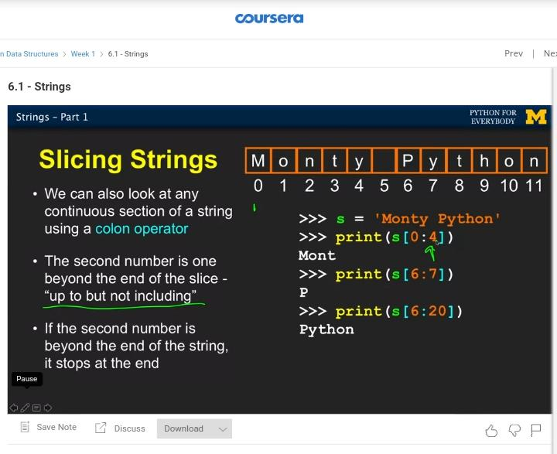

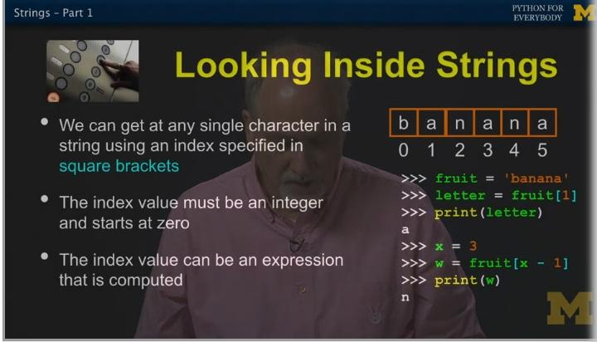

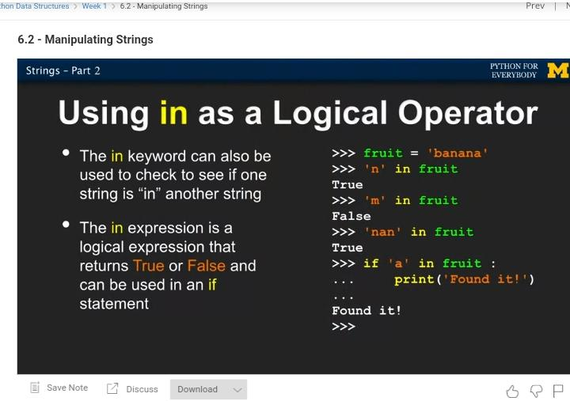

|  |  |
| --- | --- |
| **Coding Challenges** | |
| **Problem Statement: 1**.**Python Program to Find the Sum of Cosine Series.** | |
| **Status: Executed** | |
| **Uploaded the report both in Github & Slack** | **Yes** |

**Encl : snapshots of your response to challenge.**

1. ****Python Program to Find the Sum of Cosine Series.****

import math

def cosine(x,n):

cosx = 1

sign = -1

for i in range(2, n, 2):

pi=22/7

y=x*(pi/180)

cosx = cosx + (sign*(y**i))/math.factorial(i)

sign = -sign

return cosx

x=int(input("Enter the value of x in degrees:"))

n=int(input("Enter the number of terms:"))

print(round(cosine(x,n),2))

**OUTPUT**

